Course Project: Part 1
Team A
MIS581-10120: Systems Analysis, Planning & Control
May 14, 2017

MIS581-10120: Systems Analysis, Planning & Control
Course Project: Part 1

System Request Form

Date: May 9, 2017
Project Name: Team A Hotel Reservation System

Project Sponsor:

Name: Dr. Stephen Wheeler
Department: Hotel Owner
Organization: ABC Hotels
Contact Information: Phone: (214) 642-7868

Business Problem Statement:

ABC Hotel is a small, family owned hotel that currently only takes reservations over the phone. They would like to bring their business up to date technologically and offer their guests the ability to make and cancel their reservations online.

System Scope Statement:

The software solution should be Internet-accessible, allowing guests to search room availability and make or cancel reservations from any location that has an Internet connection and a web browser. Single bed hotel rooms can accommodate up to two guests and double bed rooms can accommodate up to four guests.

High-Level Functional Requirements:

The functionality of the system should include the following:
- Be internet accessible
- Allow guests to search room availability by date and number of guests
- Allow guests to make, cancel, and update hotel reservations
- Allow staff to make, cancel, and update hotel reservations on behalf of guests
- Maintain records for guest reservations
- Maintain records for room types (single or double bed)

Business Benefits:

Intangible:
Implementing this new system will provide their customers with an easy and convenient means of making reservations. It will also allow the hotel to be more competitive with their larger competitors. This system will also free up staff members to perform other tasks and cater to guests currently staying in the hotel, increasing productivity and quality customer service.

Tangible:
The system is expected to increase occupancy by up to 50% due to an increase in bookings, increasing the overall revenue of the hotel. It is also expected to decrease the number of no-show cancellations that leave rooms unoccupied because guests can easily cancel their reservations online, providing the hotel an opportunity to offer the room to another guest immediately upon cancellation.

Special Issues or Constraints:

Security must be addressed to ensure guests personal information is secure.
The project must be completed within 6 months.

Context Level Data Flow Diagram

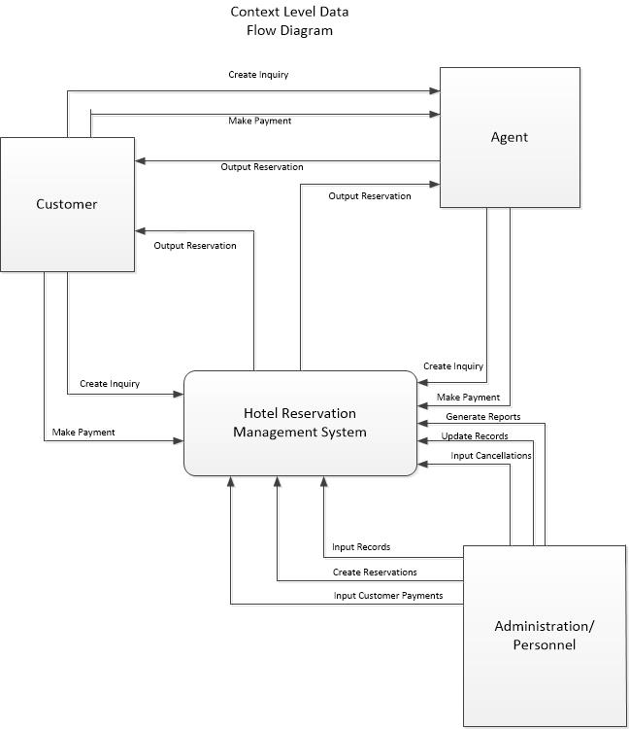
Use Case List

When customer requests for booking a room, the receptionist of the hotel looks for room availability. If there is a room available Receptionist will ask the date and time that customer wants to check-in. They will schedule the check-in check-out time. After setting up the room and date, customer should provide credit card information. Bank Department should verify if the credit card that provided by customer has enough credit to pay the room. When payment get approved by bank, payment validation will be registered to a reservation or booking system. After that, booking confirmation will send to the guest. once payment is registered in the system, client will be notified of payment received. Hotel reception department will wait for customer to arrive.

Use Case Diagram

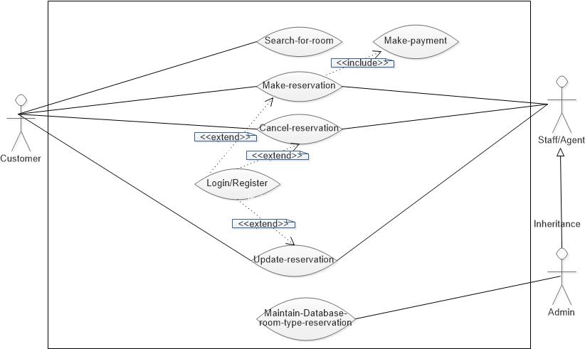

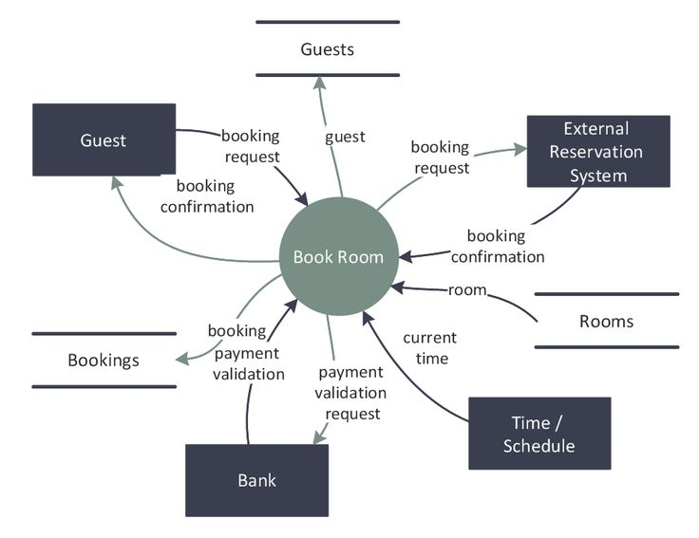

Use Case Scenarios

Use Case Description – Make a reservation

Use Case Name: Make a reservation | ID: Team A 001
Area: Hotel Reservation System
Actor(s): Reservation Requestor (Customer or Agent)
Stakeholder: Hotel Franchise
Level: Kite
Description: Allows a customer or agent to reserve, cancel, or modify a hotel reservation.
Triggering Event: The Reservation Requestor uses the gateway for hotels, enters the date/location, and clicks the Find button.
Trigger Type: External (Customer, Agent, and System initiated)
Steps Performed (Main Path) | Information for Steps
- Reservation Requester enters a gateway for hotels. | Portal Web Address
- The System requests the city and state or airport or hotel name, check-in and check-out dates, and number of rooms. | Reservation Web Form
- The Reservation Requester selects hotel, arrival and departure dates, and room type. | Reservation Web Form
- The System searches for hotels with available rooms on the specified dates near the specified location. | Reservation Web Form
- System provides availability and price. | Reservation Web Form
- The Reservation Requestor accepts and asks for a room. | Reservation Web Form
- The System allows the Reservation Requester to enter a promotion code, provides the total price (including tax and other charges), and requests the Reservation Requester to continue the reservation request. | Reservation Web Form
- The System requests customer information. | Reservation Web Form
9. The Reservation Requester inputs name and post code. | Reservation Web Form
10. The Reservation Requester inputs the customer email address. | Reservation Web Form
11. The System requests credit card information. | Secure Credit Card Web Page
12. The Reservation Requester provides credit card information. | Secure Credit Card Web Page
13. The System sends a request for credit card validation to the Credit Card Processor. | Secure Credit Card Web Page
14. The Credit Card Processor validates the credit card information. | Secure Credit Card Web Page
15. The System checks the credit card validation result. | Secure Credit Card Web Page
16. The System stores and makes a reservation and allocates a reservation number. | Confirmation Web Page, Reservation Record
17. System shows reservation number to client. | Confirmation Web Page, Reservation Record
18. The System sends an email confirmation to the customer
7. 19. System creates and sends a confirmation to the customer by email. | Reservation Record Confirmation Number
20. The System indicates an email message with the reservation information has been sent to the customer. | Reservation Record Confirmation Number
Precondition: None (that is, there are no conditions to be satisfied prior to carrying out this use case).
Alternate
Postcondition: A room of the desired type will have been reserved for the customer for the requested period and the room will be occupied for that period.
Assumption: A customer can make a reservation via the Internet. The customer is not already known to the hotel's software system.
Success Guarantee: The Customer/Agent has made/modified/cancelled a hotel reservation based on the customers’ desire.
Requirements Met: Allow Reservation Requestor (Customer or Agents) the ability to make, cancel, and/or modify a hotel reservation.
Outstanding Issues: How should a rejected credit card be handled?
Priority: High
Risk: Medium
Extensions or Alternative Scenarios

Room Selection
- A list of rooms display.
- Reservation Requester does not select a room type.
- The request is submitted.
- The system presents a message indicating that a room type must be selected.
OR
- A list of rooms display.
- Required room type not available
- System offers alternative rooms
- Client accepts and selects from alternative rooms
b. Client refuses alternatives Fail
Client declines offer Fail

Hotel Selection:
- The Reservation Requester selects the date, enters the airport and/or location
- No hotels meet the criteria.
- The system indicates there are no hotels meeting the specified criteria.
- System prompts Reservation Requester to modify selection due to no availability with search criteria.
Credit Card Issue:

- The method of payment is presented to the Reservation Requester.
- Credit card information is entered.
- Credit card information not valid.
- The system indicates the credit card information is invalid. Prompts user to check information entered.
SDiscounts
- The discounts page shows.
- Client is registered and his info already on file
- The system offers a discount

